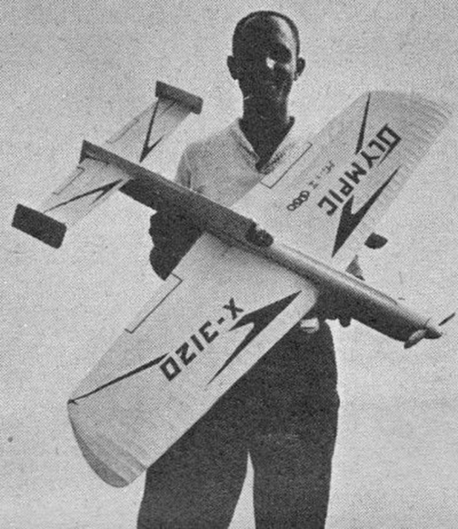


Circle Masters Flying Club  Wisconsin’s control line club |  | Lifetime Member Bob Gidildi
Announcements  Thanks Howard  Howard has been the newsletter editor for this publication for a long time. His devotion to the club and hobby is not to be doubted. Let’s hope Howard can get some time in the shop to build airplanes. Love to see his gyros and his stinky diesels. |  | Inside This Issue  PG. 2 Contact information  PG. 3 Plan of the months  PG. 4 Meeting Minutes  PG. 5 Flying and building reports  PG.6 Events

Editors Notes  The newsletter will be undergoing some changes to make is easier for the editor to manage is and for you all to contribute photos (please!) and text. We will be using google docs so anyone in the club can add to a monthly installment. Also google docs makes it easy to integrate content into the web, and hardcopies  I plan on refocusing this on building and flying activities as well as full scale stuff in the general area. I have ideas for a few dozen issues, but I need contributors, or my build logs will be featured. |  | Club Information  Web site www.circlemasters.com  Dues $25  Flying Location  Sussex Village Park, Sussex. Wisconsin  Meeting First Saturday of the month 1pm  Location Summer (May- Oct) at the field  Location Winter Sussex Library
“Winter is building season please be safe in your workshop” |  | The Prez Sez  We think the design of this newsletter is great as is! But, if you do not agree, you are able to make it yours by making a few minor design tweaks! Tips on updating specific features are available throughout this example text.  To change any of the text in this document, just click on the block of text you want to update! The formatting has already been programmed for ease of formatting.  Have other images you wish to use? It is simple to replace any of the pictures in this pamphlet. Simply do

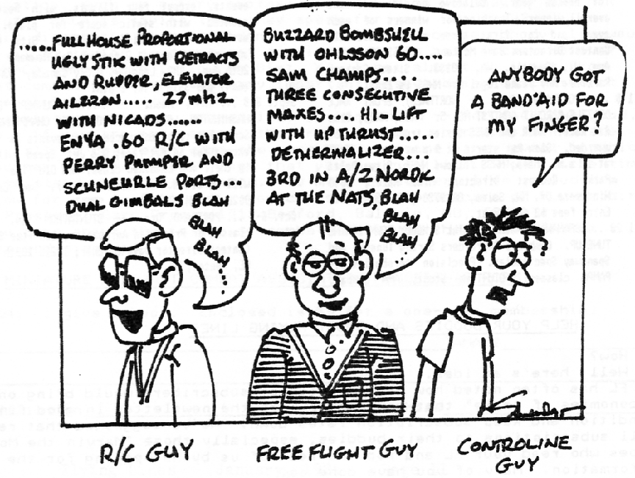  Cartoon |  | Your Title Goes Here  This is a block for a short article In the same way you change the colors, you can update the fonts of the entire document easily! From the Design tab, choose a font combination that fits your taste.  Reset the theme to restore the template to its original state!  To change any of the text in this document, just click on the block of text you want to update! The formatting has already been programmed for ease of formatting.  In this panel, you can highlight even more information about your organization! Tell the audience why you are the best! Don’t be shy! Share, explain, and tell us what makes your company so great!  Plenty of text will fit in any of these panels. Simply click on the placeholders and add your own text.
Aero Modeling has many disciplines. RC free flight control line, drone guys rocket guys. Many sub groups underneath them. While we may be different we are more alike than different and as our ranks continue to shrink, finding the common ground is important.

Club Events
Club Contest
EAA Kidventure
Steam Show
Club Fun Fly and Picnic
Christmas Party

Plan of the month
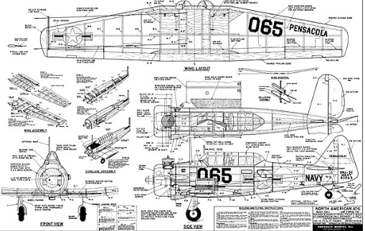

Meeting Minutes
Friday, 09.04.20XX
─

Attendees
Wendy Writer, CEO
Ronny Reader, CFO
Abby Author, CTO

Agenda

Treasurer's Report
- Daaagnabbit Blaaahge Not again 4 minutes, time me.

Reports and Announcements
- Lorem ipsum dolor sit amet, consectetuer adipiscing elit.

Old Business
- Lorem ipsum dolor sit amet, consectetuer adipiscing elit.

New Business
- Lorem ipsum dolor sit amet, consectetuer adipiscing elit.
- Suspendisse scelerisque mi a mi.

Web Site

Action Items

Calendar

Members in Action Building and Flying
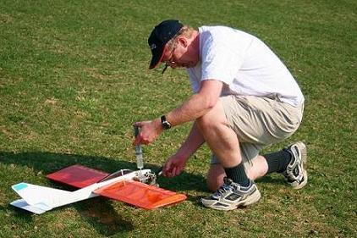


Our member at the field

JANUARY 2019
SUNDAY | MONDAY | TUESDAY | WEDNESDAY | THURSDAY | FRIDAY | SATURDAY
 |  | 1 | 2 | 3 | 4 | 5
 |  |  |  |  |  | club meeting
6 | 7 | 8 | 9 | 10 | 11 | 12
13 | 14 | 15 | 16 | 17 | 18 | 19
 |  |  |  |  |  | this
20 | 21 | building session | 23 | 24 | 25 | 26
27 | 28 | 29 | 30 | 31
NOTES

